**History and Origin of Christmas celebrations**

Christmas is for joy, for giving and sharing, for laughter, for coming together with family and friends, for tinsel and brightly decorated packages... But mostly, Christmas is for love. It was this love for which Jesus came to this world and sacrificed his life.

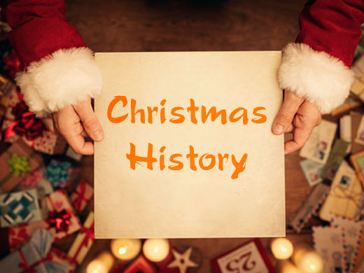

Thus Christmas is a celebration of love and mirth symbolized by the Nativity, the Santa, the caribou, the poinsettia and the evergreens. All that bring home the spirit of love and life. And this is the spirit that makes Christmas so popular throughout the world.

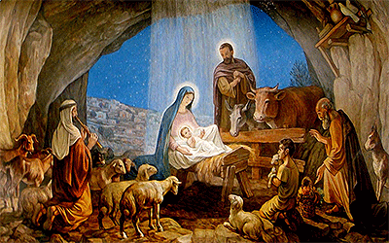

Though originated by the Roman Catholics who commemorate the December 25th as the day of birth of Christ Child, it has gradually come to be celebrated by the non-Catholics as well. As far as the United States goes, the celebration of X'mas is comparatively of recent origin. Much of the world was already well into Christmas celebrations by the time the United States began to wake up. In the first half of the 19th century the Sunday schools in America held Christmas celebrations. And the celebration of Christmas in America owes its origin to these schools. Alabama was the first state to grant legal recognition to X-mas in 1836. The DC did it in 1870. By 1893 all the states and territories had made similar acknowledgements.

So be it the United States or in other parts of the world Christmas is celebrated as the commemoration of the birth of Christ Child -- very likely the holiest event ever to take place anywhere on the Earth, and an entirely worthy occasion to celebrate. But don't we often wonder if we've got these things about it right? And why is the difference of opinion (however immaterial) regarding the date of birth? Is it even on the right date?

We bring to you a story of the Birth of Christ Child along and offer you a short tour across the world to know the way Christmas is celebrated in different parts. But before doing this please don't forget to brush up some historical trivia regarding Jesus' birth.

The whole world goes into the celebration mood during the mid winters. Long back even before the arrival of Jesus, Europeans started celebrating the light in the gloomiest days of winter. During the winter solstice, many of the Europeans began to celebrate because the tough time of winter was behind them and they felt it was the period of prolonged hours of sunlight.

Norse celebrated Yule from December 21 in Scandinavia. To celebrate the magic of sunlight, fathers and sons used logs and set them on fire. People around enjoyed these 12 days until the logs were not burned out completely. It was their belief that each fire spark represented a new pig or calf that would be born in the coming year.

Mesopotamians used to celebrate 12 days long New Year festival before 4000 years. This festival was called Zagmuth. The Mesopotamians, believers of multiple deities, started the celebration to honor their chief deity, Marduk. They used to believe that Marduk fought against the monsters of chaos at the onset of each winter season. It was believed that this was the festival where from the 12 days long Christmas had originated.

Most of the European countries thought that the end of December was an appropriate and ideal time for celebrations. It was a high time to celebrate because there were no cattle left for feeding as most of the cattle were already slaughtered. Celebration could continue with fresh meat and it was the only time of the winter when they had that opportunity. The fermented wine and beer during this time were the additional spice for the celebration.

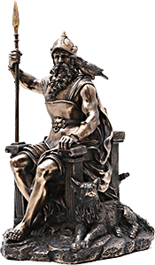

During mid winter German people honored the time-honored Pagan God Oden. People of Germany were afraid of the nocturnal sky flights. They used to think that the Almighty had created that to observe and monitor his people of this world. They had also thought that the Almighty had the power to decide who would live and who would perish. Many of them decided to stay inside due to his presence.

Places like Saturnalia, Rome where the winter was not that strong and unkind like countries located in the northern tip celebrated holidays in honor of the God of agriculture, Saturn. Beginning in the week leading up to the winter solstice was a special period when residents had bountiful food items and drinks to celebrate with. The month long celebration had the charm to convert slaves to even masters. Peasants used to control the city. To celebrate the time with fun and frolic all the schools and business organizations had decided to close their shutters.

Juvenalia, the feast honoring the Children of Rome, celebrated during winter solstice, was a prime carnival for Roman people as well. On December 25, the upper class of Rome used to celebrate the birthday of the infant God of the unconquerable sun, Mithra who was born of a rock. It was the most sanctified day of the entire year for few Romans. Easter, the main holiday, was celebrated in the early years of Christianity. However, Christmas or the birth of Jesus was not celebrated.

Romans started to exchange gifts and visit the homes of their friends and relatives during the festivity. It was believed that the ritual of exchanging greeting and gifts during Christmas had come from Rome.

# Christmas in the United Kingdom

In the UK (or Great Britain), families often celebrate Christmas together, so they can watch each other open their presents!

Most families have a [Christmas Tree](https://www.whychristmas.com/customs/trees.shtml) (or maybe even two!) in their house for Christmas. The decorating of the tree is usually a family occasion, with everyone helping. Christmas Trees were first popularised the UK by Prince Albert, the husband of Queen Victoria. Prince Albert was [German](https://www.whychristmas.com/cultures/germany.shtml), and thought that it would be good to use one of his ways of celebrating Christmas in to England.

[Holly, Ivy](https://www.whychristmas.com/customs/hollyandivy.shtml) and [Mistletoe](https://www.whychristmas.com/customs/mistletoe.shtml) are also sometimes used to decorate homes or other buildings.

Most villages, towns and cities are decorated with Christmas lights over Christmas. Often a famous person switches them on. The most famous Christmas lights in the UK are in Oxford Street in London. Every year they get bigger and better. Thousands of people go to watch the big 'switch on' around the beginning of November.

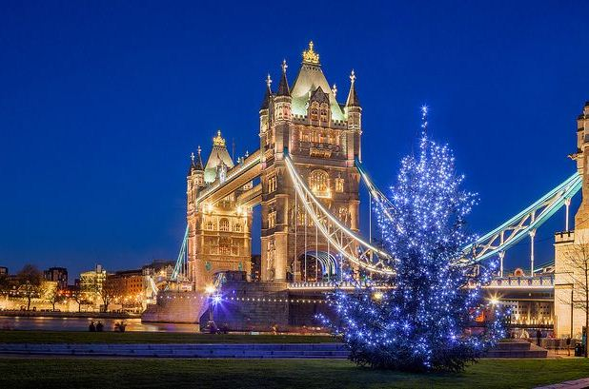

Like a lot of countries, [Nativity Plays](https://www.whychristmas.com/customs/nativity.shtml) and [Carol](https://www.whychristmas.com/customs/carols.shtml) Services are also very popular at Christmas time. The Church that I go to always has a Carols by Candlelight Service where the church is only lit up by candles. It is a very special service and always makes me feel very Christmassy! Lots of other British churches also have Carols by Candlelight and [Christingle](https://www.whychristmas.com/customs/christingles.shtml) services.

Children believe that [Father Christmas or Santa Claus](https://www.whychristmas.com/customs/fatherchristmas.shtml) leaves [presents](https://www.whychristmas.com/customs/presents.shtml) in stockings or pillow-cases. These are normally hung up by the fire or by the children's beds on Christmas Eve. Children sometimes leave out [mince pies](https://www.whychristmas.com/customs/mincepies.shtml)and brandy for Father Christmas to eat and drink when he visits them. Now, some people say that a non-alcoholic drink should be left for Santa as he has to drive!

Children write letters to Father Christmas/Santa listing their requests, but sometimes instead of putting them in the post, the letters are tossed into the fireplace. The draught carries the letters up the chimney and Father Christmas/Santa reads the smoke.

There are some customs that only take place, or were started, in the UK. [Wassailing](https://www.whychristmas.com/customs/wassailing.shtml) is an old anglo-saxon custom that doesn't take place much today. [Boxing Day](https://www.whychristmas.com/customs/boxingday.shtml) is a very old custom that started in the UK and is now taken as a holiday in many countries around the world.

In Scots (a Scottish dialect) Happy/Merry Christmas is 'Blithe Yule'; in Gaelic it's 'Nollaig Chridheil'; in Welsh (which is spoken in some parts of Wales it's 'Nadolig Llawen', in Cornish (spoken by some poeple in Cornwall in south west England) it's 'Nadelik Lowen' and Manx (spoken by some people on the Isle of Man) it's 'Nollick Ghennal'. [Happy/Merry Christmas in lots more languages](https://www.whychristmas.com/customs/languages.shtml).

In the UK, the main Christmas Meal is usually eaten at lunchtime or early afternoon on Christmas Day. It's normally roast turkey, roast vegetables and 'all the trimmings' which means vegetables like carrots & peas, stuffing and sometimes bacon and sausages. It's often served with cranberry sauce and bread sauce. Traditionally, and before turkey was available, roast beef or goose was the main Christmas meal. One vegetable that is often at Christmas in the UK are brussel sprouts. I love them but lots of people don't!

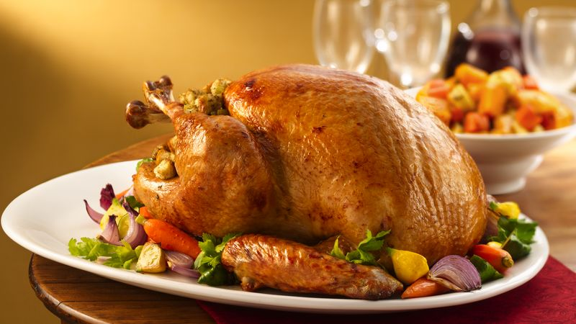

Dessert is often [Christmas Pudding](https://www.whychristmas.com/customs/pudding.shtml). Mince pies and lots of chocolates are often eaten as well!

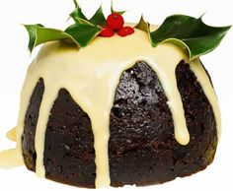

Trifle is also a popular dessert at Christmas. It's made in a large bowl and consists of a layer of sponge cake (or sponge fingers) at the bottom of the bowl (which is often soaked in sherry or brandy) then there's a layer of fruit (normally suspended in a fruit flavored jelly) and it's topped with a layer of custard and then whipped cream. In Scotland there's a variation called 'Tipsy Laird' which uses whiskey to soak the sponge and the fruit are raspberries.

The dinner table is decorated with a [Christmas Cracker](https://www.whychristmas.com/customs/crackers.shtml) for each person and sometimes flowers and candles.

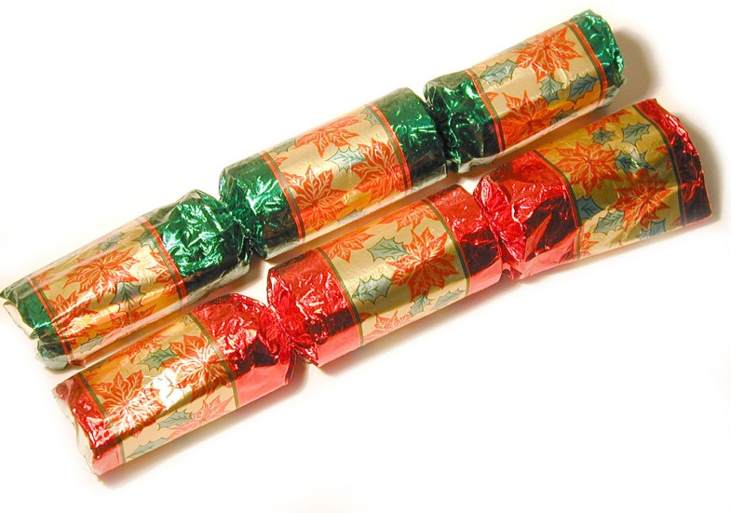

The UK is also famous for [Christmas Cake](https://www.whychristmas.com/fun/recipe_christmas_cake.shtml) - some people love it and some people really don't like it! It's traditionally a rich fruit cake covered with marzipan and icing - and often top with Christmas themed cake decorations like a spring of holly.

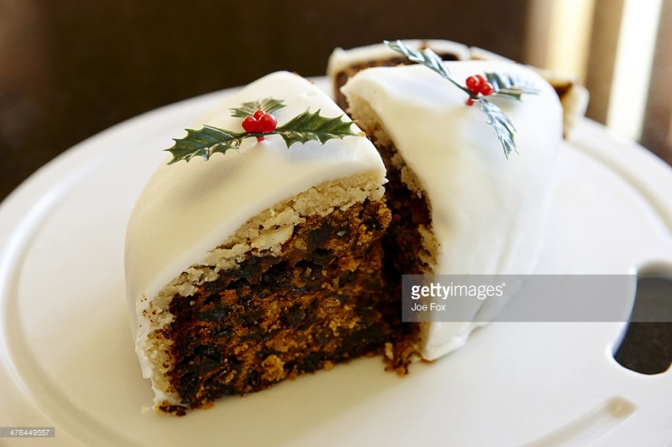

In the UK, it doesn't snow very often, but people always want to know if it will be a 'White Christmas'. The British definition, used by the UK Meteorological Office (who say if it has been a White Christmas in the UK or not!), is that a single snow flake has been seen falling in the 24 hours of Christmas Day! This doesn't happen a lot in the UK!!!

Statistics show that in the UK, they get an official White Christmas about every 4 or 5 years and have real snow at Christmas about 1 in 10 years (but often this is only normally in Scotland!).

One sure way of getting some snow into Christmas in the UK is by watching the popular cartoon 'The Snowman' which is about a boy's adventure when his snowman comes to life. The animation was first shown on UK TV on Boxing Day in 1982. It's based on story book of the same name by the children's author and illustrator Raymond Briggs. For many families, it's now a 'must watch' over Christmas. (When I was at Primary/Elementary School in the 1980s, it was always shown to the school on the last morning before the Christmas holidays!) The Snowman also featured the song "Walking in the Air". In the animation, it was sung by Peter Auty, a choirboy at St Paul's Cathedral in London. However, the song became very famous in 1985 when it was used in a Christmas TV advert for the 'Toys "R" Us' chain in the UK. This time, it was sung by a choirboy called Aled Jones. Aled Jones is now an adult and is a TV and Radio presenter! The song has been recorded by lots of different people and groups (including an adult Aled singing a duet with his younger self) and is now a real UK 'Christmas classic'! In 2012 a sequel to The Snowman called "The Snowman and the Snowdog" was shown on Christmas Eve.

In Scotland, some people celebrate New Year's Eve (which is called Hogmanay) more than Christmas! The word Hogmanay comes from a kind of oat cake that was traditionally given to children on New Year's Eve.

All across the UK, in cities and towns, there are fireworks to celebrate the New Year. Two of the most famous fireworks displays are in London, along the River Thames, and in Edinburgh at the Hogmanay celebrations.

Also in Scotland, the first person to set foot in a house in a New Year is thought to have a big effect on the fortunes of the people that live there! Generally strangers are thought to bring good luck. Depending on the area, it may be better to have a dark-haired or fair-haired stranger set foot in the house. This tradition is widely known as 'first footing'. In England it is sometimes said that a stranger coming through the door carrying a lump of coal will bring good luck.

